AI Assisted coding
Assignment-3.1
B.Tejaswi
2303A52123
Batch-40
Question 1: Zero-Shot Prompting (Palindrome Number Program)
Write a zero-shot prompt (without providing any examples) to generate
a Python function that checks whether a given number is a palindrome.
Task:
• Record the AI-generated code.
• Test the code with multiple inputs.
• Identify any logical errors or missing edge-case handling.

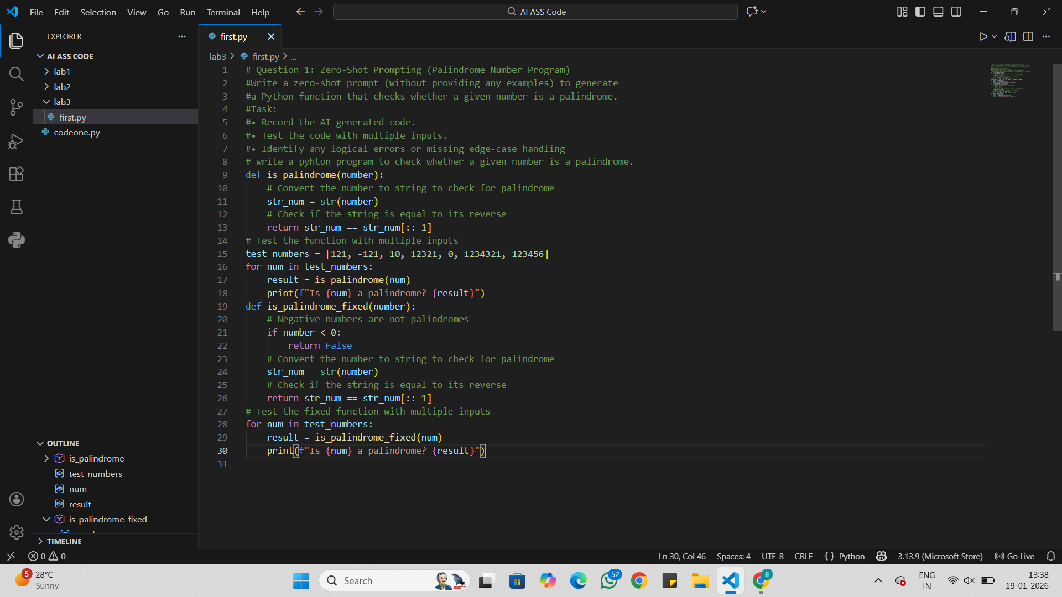

Output:
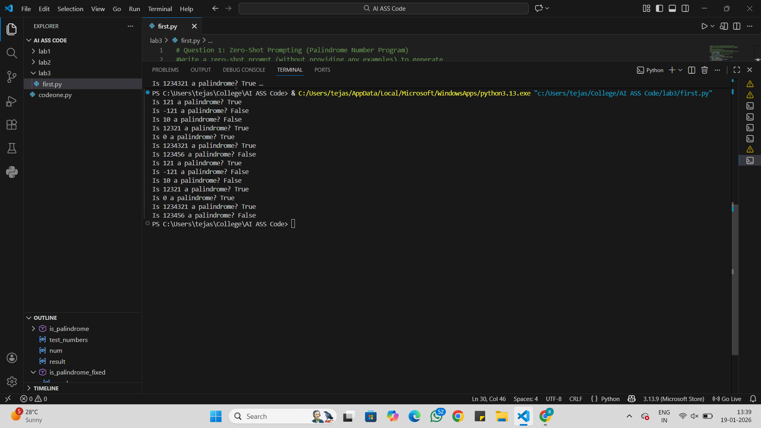
Analysis:
Works correctly for basic positive numbers
Negative numbers fail due to string behavior, not real logic
No input type checking is done
Relies only on string conversion
Suitable only for simple or beginner-level tasks

Question 2: One-Shot Prompting (Factorial Calculation)
Write a one-shot prompt by providing one input-output example and
ask the AI to generate a Python function to compute the factorial of a
given number.
Example:
Input: 5 → Output: 120
Task:
• Compare the generated code with a zero-shot solution.
• Examine improvements in clarity and correctness.
Output:
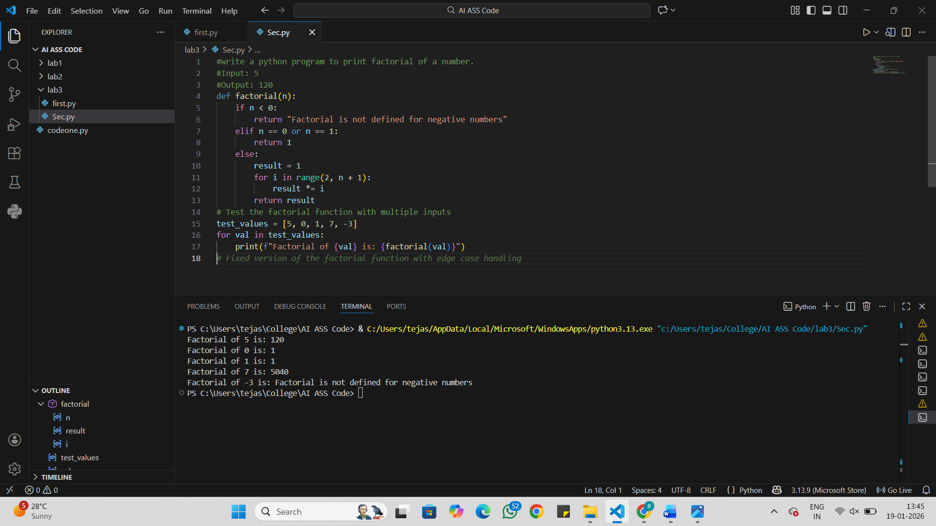
Anlysis:
One-shot code clearly handles the base case (0! = 1)
Zero-shot version misses explicit handling of zero
One-shot solution is easier to understand and more structured
One-shot result is mathematically more correct
Example helps the AI generate safer and clearer logic.

Question 3: Few-Shot Prompting (Armstrong Number Check)
Write a few-shot prompt by providing multiple input-output examples
to guide the AI in generating a Python function to check whether a
given number is an Armstrong number.
Examples:
• Input: 153 → Output: Armstrong Number
• Input: 370 → Output: Armstrong Number
• Input: 123 → Output: Not an Armstrong Number
Task:
• Analyze how multiple examples influence code structure and
accuracy.
• Test the function with boundary values and invalid inputs.
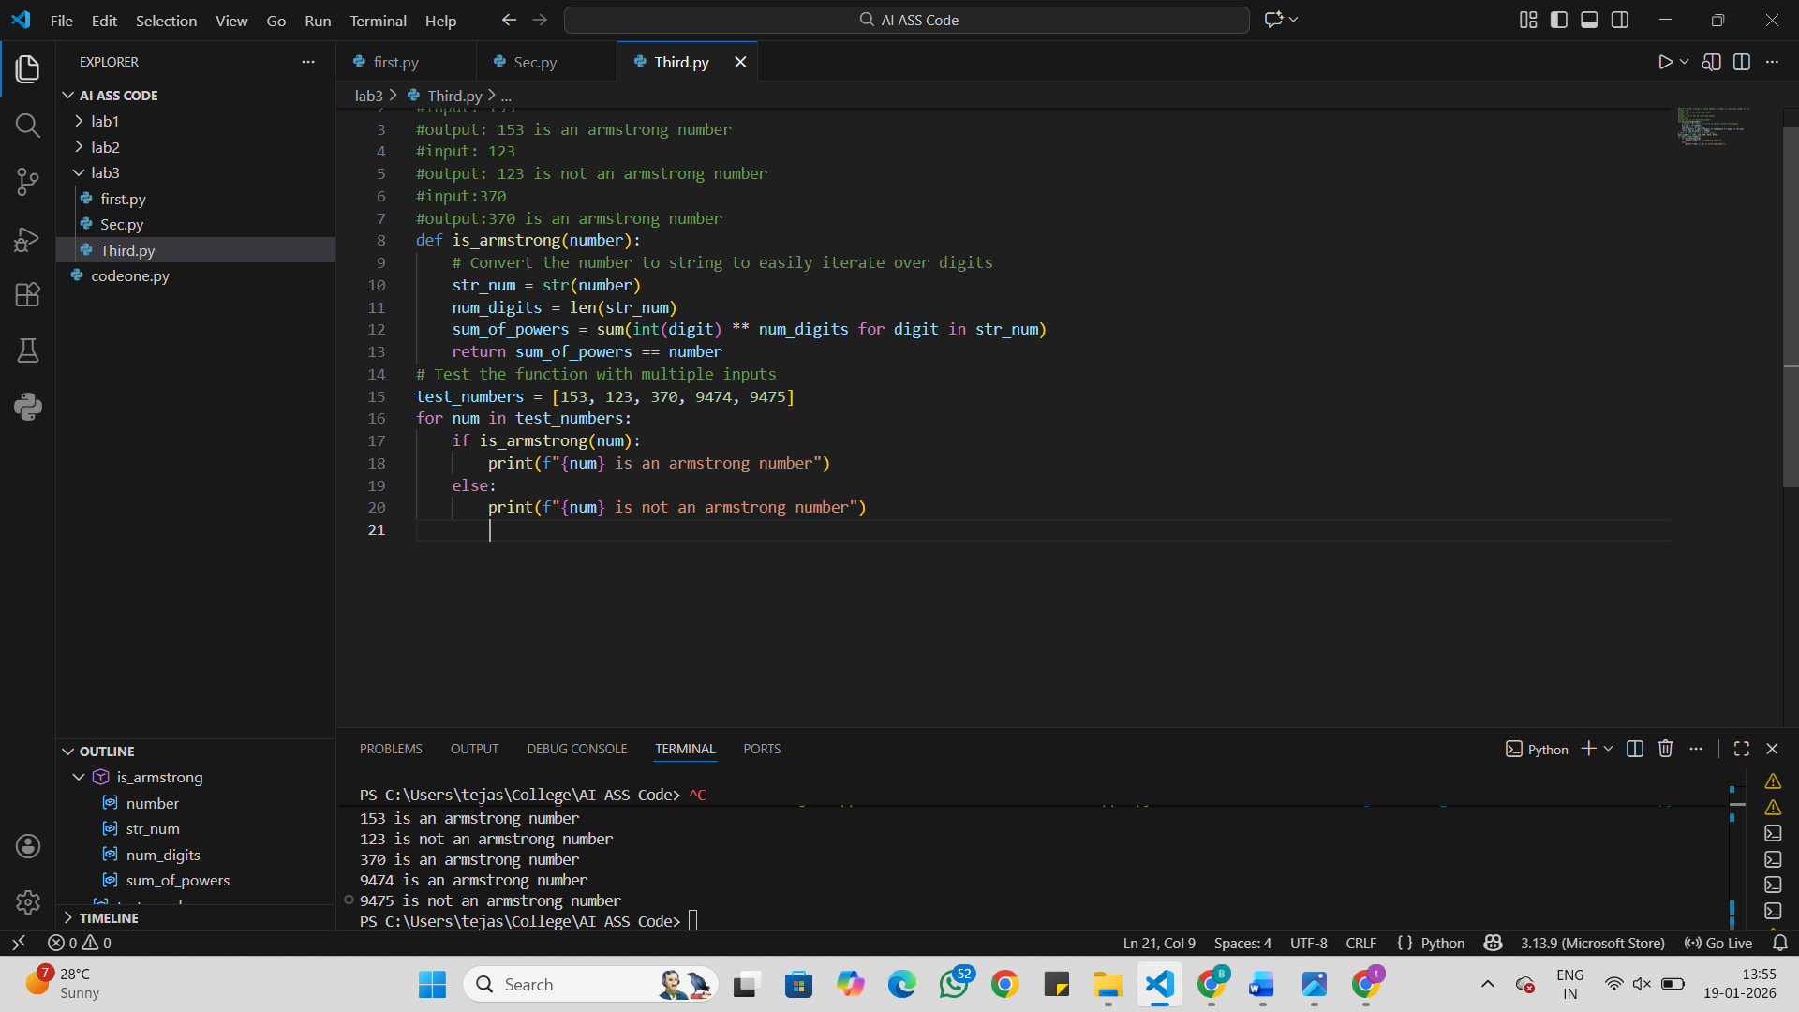
Analysis:
Giving examples helps the AI understand what kind of answer is expected.
Multiple examples make the code cleaner and more logical.
Showing both correct and incorrect cases avoids confusion.
Testing small numbers like 0 and 1 ensures the function works properly.
Checking wrong inputs makes the program safer and more reliable.

Question 4: Context-Managed Prompting (Optimized Number
Classification)
Design a context-managed prompt with clear instructions and
constraints to generate an optimized Python program that classifies a
number as prime, composite, or neither.
Task:
• Ensure proper input validation.
• Optimize the logic for efficiency.
• Compare the output with earlier prompting strategies.
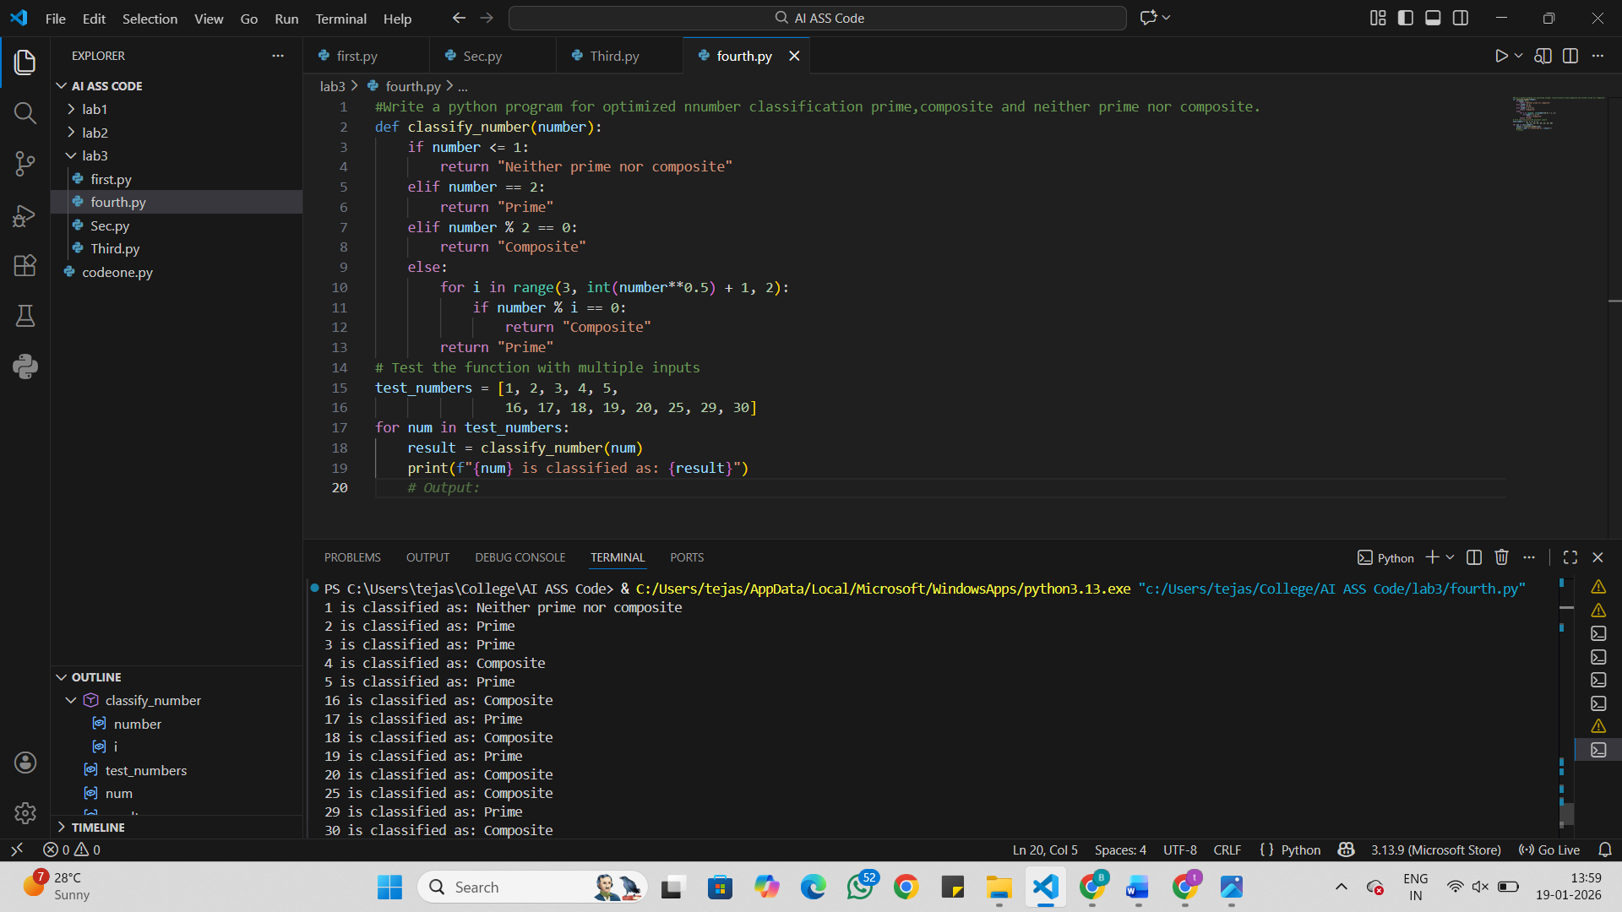
Analysis:
Clear instructions help the AI understand exactly what is needed.
Input validation avoids crashes from wrong inputs.
Efficient logic makes the program faster and smarter.
The AI performs better than with simple prompts.
Results are clearer and more reliable.

Question 5: Zero-Shot Prompting (Perfect Number Check)
Write a zero-shot prompt (without providing any examples) to
generate a Python function that checks whether a given number is a
perfect number.
Task:
• Record the AI-generated code.
• Test the program with multiple inputs.
• Identify any missing conditions or inefficiencies in the logic.
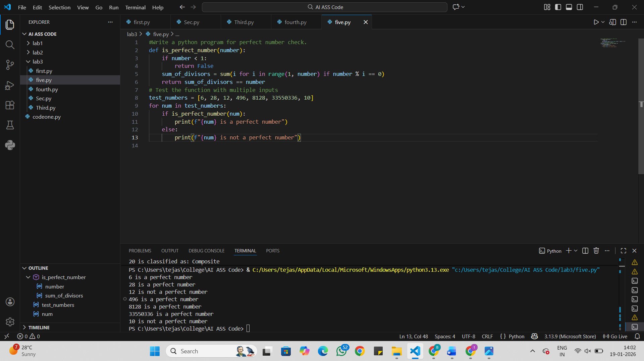
Analysis:
The AI works only with instructions, no examples.
The code usually works but may miss some cases.
Testing with different numbers shows if it’s correct.

The logic may be slower without optimization.
Extra checks improve accuracy.

Question 6: Few-Shot Prompting (Even or Odd Classification with
Validation)
Write a few-shot prompt by providing multiple input-output
examples to guide the AI in generating a Python program that
determines whether a given number is even or odd, including proper
input validation.
Examples:
• Input: 8 → Output: Even
• Input: 15 → Output: Odd
• Input: 0 → Output: Even
Task:
• Analyze how examples improve input handling and output
clarity.
• Test the program with negative numbers and non-integer inputs.
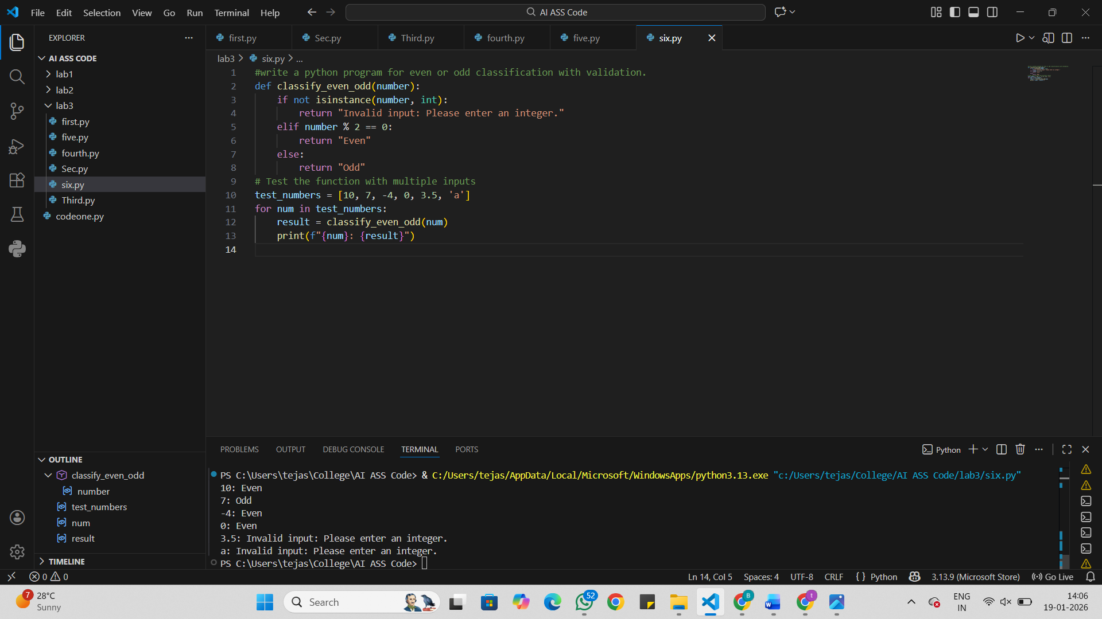
Analysis:
Examples make the task easy to understand.
The AI gives clear even or odd results.
Input validation improves with examples.
Negative numbers are handled properly.
Wrong inputs are easier to detect.

